August Breakfast Menu

 | Monday | Tuesday | Wednesday | Thursday | Friday
Aug 5-9 |  | NO SCHOOL | SUMMER | VACATION
Aug  12-16 |  |  | 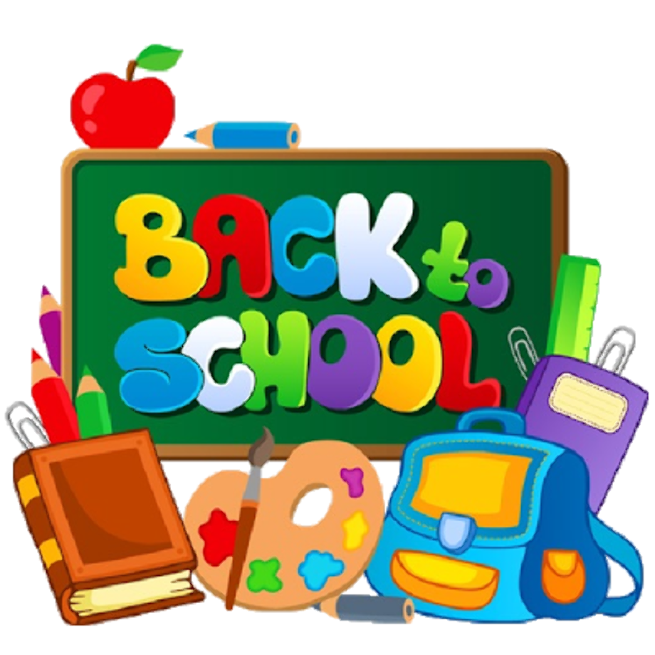
Aug  19-23 | NO SCHOOL | Scrambled Eggs  Wheat Toast  Orange Slices  Choice of Milk | Cinnamon Roll  Pears  Choice of Milk | Waffle with Syrup  Strawberries  Turkey Sausage  Choice of Milk | Cereal with Milk  Chef’s Choice of Fruit  100% Fruit Juice
Aug  26 - 30 | Cereal Bar  Cheese Stick  Applesauce  Choice of Milk | Turkey Sausage Biscuit Sandwich  Hashbrown  Pears  Milk | French Toast Sticks with Syrup  Mixed Berries  Choice of Milk | Egg and Cheese Breakfast Wrap  Banana  Choice of Milk | Cereal with Milk  Chef’s Choice of Fruit  100% Fruit Juice

August Lunch Menu

 | Monday | Tuesday | Wednesday | Thursday | Friday
Aug 5-9 |  | NO SCHOOL | SUMMER | VACATION
Aug
12-16
Aug  19-23 | NO SCHOOL | Sweet and Sour Chicken  Veggie Fried Rice  Pineapple  Choice of Milk | Turkey and Cheese Sub Sandwich  Sunchips  Carrots with Ranch  Apple  Choice of Milk | Cheese Pizza  Italian Salad  Grapes  Choice of Milk | Chicken and Cheese Quesadilla  Black Bean Salsa  Sweet Corn  Orange Slices  Choice of Milk
Aug  26 - 30 | Cheeseburger on a Wheat Bun  Tater Tots  Green Beans  Melon  Choice of Milk | Orange Chicken over Brown Rice  Broccoli  Pineapple  Choice of Milk | Beef and Bean Burrito  Black Bean Salsa  Sweet Corn  Peaches  Choice of Milk | Cheese Ravioli with Marinara Sauce  Caesar Salad  Grapes  Choice of Milk | Chicken Philly Sandwich  Sweet Potato Fries  Banana  Choice of Milk

August Snack Pre-K Menu

 | Monday | Tuesday | Wednesday | Thursday | Friday
Aug 5-9 |  | NO SCHOOL | SUMMER | VACATION
Aug
12-16
Aug  19-23 | NO SCHOOL | String Cheese  Whole Wheat Crackers  100% Fruit Juice | Trail Mix  (Cheerios, Raisins)  Milk | Applesauce  Graham Crackers  Milk | Goldfish  Raisins  Milk
Aug  26 - 30 | Animal Crackers  Fresh Fruit  Milk | String Cheese  Whole Wheat Crackers  100% Fruit Juice | Trail Mix  (Cheerios, Raisins)  Milk | Applesauce  Graham Crackers  Milk | Goldfish  Raisins  Milk

Upper Academy Salad Bar Menu
August 20 - September 27

Salad Bar Menu
Salad Base | Vegetables | Proteins | Cold Items | Dressings
Romaine Lettuce | Cherry Tomatoes  Shredded Carrots  Red/Green Peppers  Cucumber  Black Olives | Shredded Cheese  Turkey  Hard Boiled Eggs | Dinner Rolls  Croutons  Whole Fruit | Ranch  Italian

August Snack Kindergarten Menu

 | Monday | Tuesday | Wednesday | Thursday | Friday
Aug 5-9 |  | NO SCHOOL | SUMMER | VACATION
Aug
12-16
Aug  19-23 | NO SCHOOL | String Cheese  100% Juice | Trail Mix  (Cheerios, Raisins)  Water | Wheat Thins  100% Juice | Raisins  Milk
Aug  26 - 30 | Animal Crackers  Milk | String Cheese  100% Juice | Trail Mix  (Cheerios, Raisins)  Water | Wheat Thins  100% Juice | Raisins  Milk

