Dear Parent/Guardian,

We are pleased to offer access to the Momentum Academy Student Information System, Infinite Campus’ Parent Portal for the 2023-24 school year. Through the portal you will be able access your scholar’s gradebook, view daily attendance, view missing assignments, and submit requests for address and contact information updates.

A user account has been created for you, if you were listed as the scholar’s guardian during enrollment or have submitted guardianship change information to the main office.

Additionally, please make sure that there is an email address for you on file with the main office, if you will need to utilize the forgotten password feature in the portal.

To access the parent portal, visit:

https://momentummo.infinitecampus.org/campus/portal/parents/momentum.jsp

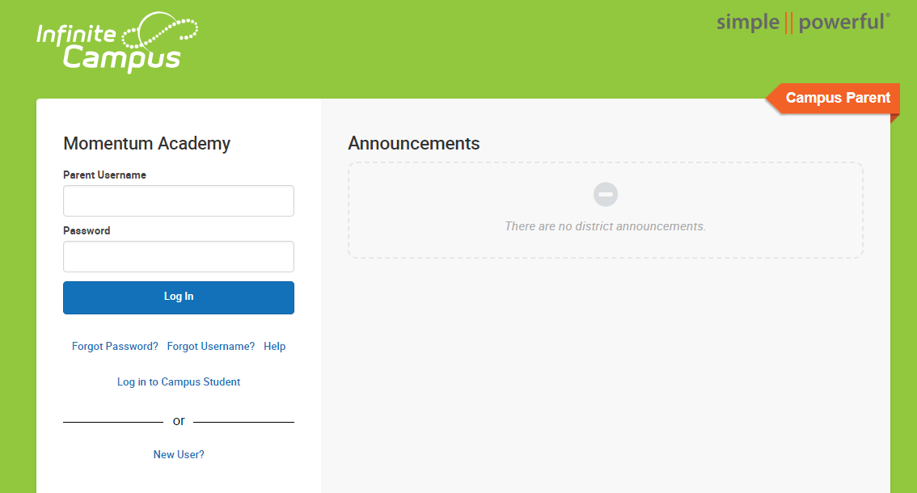

Your username will be PARENTFIRSTNAME.PARENTLASTNAME
Your password is preset to Panther23!

You will be prompted to change your password after signing in.

If you have any trouble signing in, please reach out to our tech team at techsupport@momentumacademystl.org

We hope this increase in communication regarding your scholar’s progress throughout the year will enable us to be better partners in your child’s education.

